CISC7204 — Revised Pair Project Proposal
Analysing Consumer Purchasing Behaviour: A Two-Dataset Credibility Audit and Spending-Driver Study
Housekeeping item | Detail
Course Code | CISC7204
Course Title | Data Science and Data Visualization
Coursework Item | Assignment 02 — Pair Project Proposal
Class / Pair | Class B, Pair 05
Member 1 | QU YING — Student ID MC641326
Member 2 | LIU ZIXUAN — Student ID MC641811

Executive Summary
This proposal revises the Assignment 01 individual topic into a pair-based study, and the revision is driven by an empirical finding rather than a change of interest. The Shopping Behaviour dataset that anchored the original proposal turns out to contain almost no usable association with its own outcome: the three strongest candidate predictors correlate at r = 0.008, r = -0.010 and r = 0.031 with purchase amount, and one-way ANOVA across eight grouping variables returns p > 0.05 in every case except Season (p = 0.011). A dataset in which nothing predicts the outcome cannot answer the original question, so the project keeps it as an explicit audit case and moves the modelling onto the Customer Personality Analysis dataset, which does carry structure: income r = 0.668, catalogue purchases r = 0.780 and young children at home r = -0.558 against total spend.

1. Project Topic Name

1.1 Project Title
Analysing Consumer Purchasing Behaviour: A Two-Dataset Credibility Audit and Spending-Driver Study

1.2 Region and 1.3 Domain Category
Region: United States — both datasets describe US-based retail and direct-marketing customers. Domain category: Consumer Behaviour and Retail Analytics.

1.4 Research Question
Main question — How strongly are customer demographics and shopping behaviour associated with purchase amount, and how far can that association be trusted once the underlying data are audited for credibility?
Four sub-questions structure the work:
- RQ1 (credibility): Do the Shopping Behaviour variables show any reliable association with purchase amount, or is the dataset effectively signal-free? Tested with correlation, one-way ANOVA and effect sizes.
- RQ2 (drivers): In the Customer Personality Analysis data, how much of the variation in total spend is explained by income, household composition and channel purchase behaviour? Tested with correlation screening and multiple regression.
- RQ3 (segments): Can distinct customer value segments be identified, and do they differ in campaign response rate? Tested with K-Means clustering and group comparison.
- RQ4 (methodological): What does the contrast between a signal-free synthetic dataset and a structured real one imply for evidence-based retail decision making?

2. Project Purpose

2.1 Outcomes
The project connects directly to the CISC7204 learning outcomes on importing, cleaning, exploratory analysis, visualisation, inference and reproducible reporting. It reframes rather than abandons the Assignment 01 topic: the same question is pursued, but now answered with a documented judgement about which evidence can bear the weight of the conclusion — the response recommended in the project ideation guidance when a dataset or an analysis looks flawed. The practical skill both members want from the course is knowing which numbers to trust before acting on them, and that is precisely what the audit half of the project exercises.

2.2 Skills
- Importing and cleaning data with Python and Pandas: missing values, duplicates, invalid categories, type conversion and outlier handling.
- Auditing a dataset for credibility before modelling it: correlation screening, group comparison, effect sizes and significance interpretation.
- EDA and visualisation with Matplotlib and Seaborn: scatter plots, boxplots, bar charts with thresholds, correlation heatmaps and cluster profiles.
- Statistical inference and modelling: one-way ANOVA, correlation testing, multiple regression with diagnostics.
- Unsupervised segmentation with K-Means, plus reproducible reporting in a shared Jupyter Notebook.

2.3 Knowledge
The project builds knowledge of consumer purchasing behaviour, demographics, channel mix and household effects on spend, and of customer value segmentation. It also builds a competence that is rarely taught explicitly: distinguishing a dataset that contains structure from one that does not. Both datasets are observational and cross-sectional, so association is reported as association and no causal claim is made. This is stated up front as an analytical constraint rather than appended as a caveat at the end.

3. Project Tasks
Tasks are mapped to the seven stages of the data science project workflow presented in Tutorial 09 (Ken Jee, Data Science Project From Scratch), with completion status at the time of writing.
Stage | Task and deliverable | Status
1 Planning | Define question, sub-questions, datasets and success criteria. Deliverable: this revised proposal. | Complete
2 Collection | Acquire both datasets; run the credibility audit that drives the re-scope. Deliverable: audit figure and finding log. | Substantially complete
3 Cleaning | 24 missing incomes, extreme values (income 666,666; birth year 1893), invalid categories (Absurd, YOLO), date parsing. Deliverable: cleaned frames and cleaning log. | Started
4 EDA | Distributions, group comparisons, correlation matrices, synthetic-versus-real contrast. Deliverable: annotated notebook section. | Started
5 Modelling | Regression of total spend on income, household and channel variables; K-Means segmentation. Deliverable: models, diagnostics, cluster profiles. | Not started
6 Delivery | Reproducible notebook plus a consolidated visual summary; no production deployment at this scale. | Not started
7 Documentation | Final notebook, written interpretation, limitations and reproducibility notes. | Not started

Stages 1 and 2 are complete and stages 3 and 4 are underway; stages 5 to 7 are planned and scheduled. The pair expects stages 1 to 5 to be complete before final submission, with 6 and 7 delivered as the reporting package.

3.1 Data Quality Issues Identified So Far
Dataset | Issue | Planned treatment
marketing_campaign.csv | Tab-separated, not comma-separated; 24 missing Income values | Read with sep='\t'; drop rows with missing Income
marketing_campaign.csv | Extreme values: Income 666,666; Year_Birth 1893 (age 131) | Filter Age < 100; flag extreme income as outlier
marketing_campaign.csv | Invalid marital status categories (Absurd, YOLO); Dt_Customer is a string | Recode to a single category; parse to datetime
marketing_campaign.csv | Spend is spread across six product columns | Sum into a single Total Spend variable
shopping_behavior_updated.csv | No missing values, but no signal against the outcome either | Retained as the audit case; not used for modelling

4. Analytical Plan
Question | Method | Expected evidence
RQ1 | Pearson correlation; one-way ANOVA across eight groups | Correlation table, ANOVA p-values, effect sizes (eta squared)
RQ2 | Multiple linear regression of Total Spend on income, household and channel variables | Coefficients, R-squared, residual and influence diagnostics
RQ3 | K-Means on scaled behavioural variables; elbow and silhouette check | Cluster count justification, segment profile table, response rates
RQ4 | Comparative discussion of the two datasets | Written argument supported by the audit figure

5. Project Criteria for Success
The finished product is a reproducible Jupyter Notebook plus a short written report. It will be judged successful against the following checklist, which both members will apply before submission.
Criterion | Concrete standard to be met
Data preparation | Both datasets imported and inspected; missing values, duplicates, invalid categories and outliers handled; cleaning logged and reproducible.
Credibility audit | The signal-free result is reported with statistics, not omitted; the reasons for shifting analytical weight are stated explicitly.
Analysis quality | Each of RQ1–RQ4 answered with an appropriate method; effect sizes and significance reported; regression diagnostics shown.
Visualisation | At least one scatter plot, one bar chart with a threshold line, one boxplot and one heatmap; every figure titled, labelled and on a readable scale.
Interpretation | Findings tied to the research question; association distinguished from causation; the contrast explained in business terms.
Reproducibility | Notebook runs top to bottom in the shared environment; data files alongside; library versions recorded.

The pair will self-assess against this table before submitting and will state in the final report which criteria are fully met and which are only partially met.

6. Project Collaboration

6.1 Division of Work
Workstream | QU YING (MC641326) | LIU ZIXUAN (MC641811)
Stage 1 — Planning | Co-lead: question and criteria | Co-lead: datasets and scope
Stage 2 — Collection | Lead: acquisition and audit | Support: verification of audit
Stage 3 — Cleaning | Lead: missing values, outliers, types | Support: independent re-check
Stage 4 — EDA | Support: numeric analysis | Lead: distributions and visual profiling
Stage 5 — Modelling | Support: regression diagnostics | Lead: regression and clustering
Stage 6 — Delivery | Support: figure review | Lead: visual summary assembly
Stage 7 — Documentation | Lead: notebook write-up and report | Support: review and sign-off

Each stage has one lead who is accountable for delivery and one supporter who reviews the output before it is accepted. No stage is left to a single person without review.

6.2 Group Structure and Roles
- Project Coordinator — LIU ZIXUAN: convenes meetings, keeps the workflow sequence on track, and is the point of contact for scope changes.
- Project Scribe — QU YING: records decisions, maintains the cleaning and audit log, and drafts the written deliverables.
- Project Progress Tracker — QU YING: maintains the stage checklist against the Criteria for Success table and flags slippage early.
- Project Liaison — LIU ZIXUAN: posts required updates to the collaborative forum and confirms that both members' submissions are consistent.

6.3 Ground Rules
- One synchronous meeting per week, with a written summary posted to the collaborative forum afterwards; asynchronous updates in between.
- All code and data live in a shared folder so that either member can run the full notebook at any time; the notebook must run top to bottom before any submission.
- Every analytical result is reproduced independently by the second member before it is written into the report; disagreements are resolved by re-running the code together rather than by negotiation.
- If one member cannot meet a deadline, the other is informed at least forty-eight hours in advance so the stage lead can be reassigned.
- Both members submit the same artifacts and both declare the partnership at their own submission link and personal forum, as required.

7. Visualisation Justification
Figure 1 is the evidence behind the re-scoping decision and is the central visual argument of the revised proposal. The upper panel places the absolute correlation with the spending outcome for both datasets on one axis, ordered from strongest to weakest: the five green bars (Customer Personality Analysis) reach 0.780, 0.676 and 0.529, while the three red bars (Shopping Behaviour) sit at 0.031, 0.010 and 0.008, all far below the weak-association line drawn at |r| = 0.1. The lower panel confirms this with a different technique: across eight grouping variables only Season crosses alpha = 0.05 (p = 0.011), the rest returning p values between 0.23 and 0.87.
This addresses the research question directly, because the question asks how far an observed association can be trusted: a reader can see in one image why no spending model is built on the Shopping Behaviour data. The figure therefore does not merely illustrate a finding; it justifies the analytical design of the whole project.
Figure 2 shows the relationships that will carry the modelling work. Income against total spend gives r = +0.668, catalogue purchases against total spend gives r = +0.780, and the number of young children at home gives r = -0.558 — a negative association that is easy to miss in a table but immediately visible as a downward trend line. Together the two figures move the argument from 'one dataset is unusable' to 'here is what actually drives spend', the sequence the final report will follow. They will be complemented by a correlation heatmap, boxplots of spend by household type and cluster profiles for the RQ3 segments.
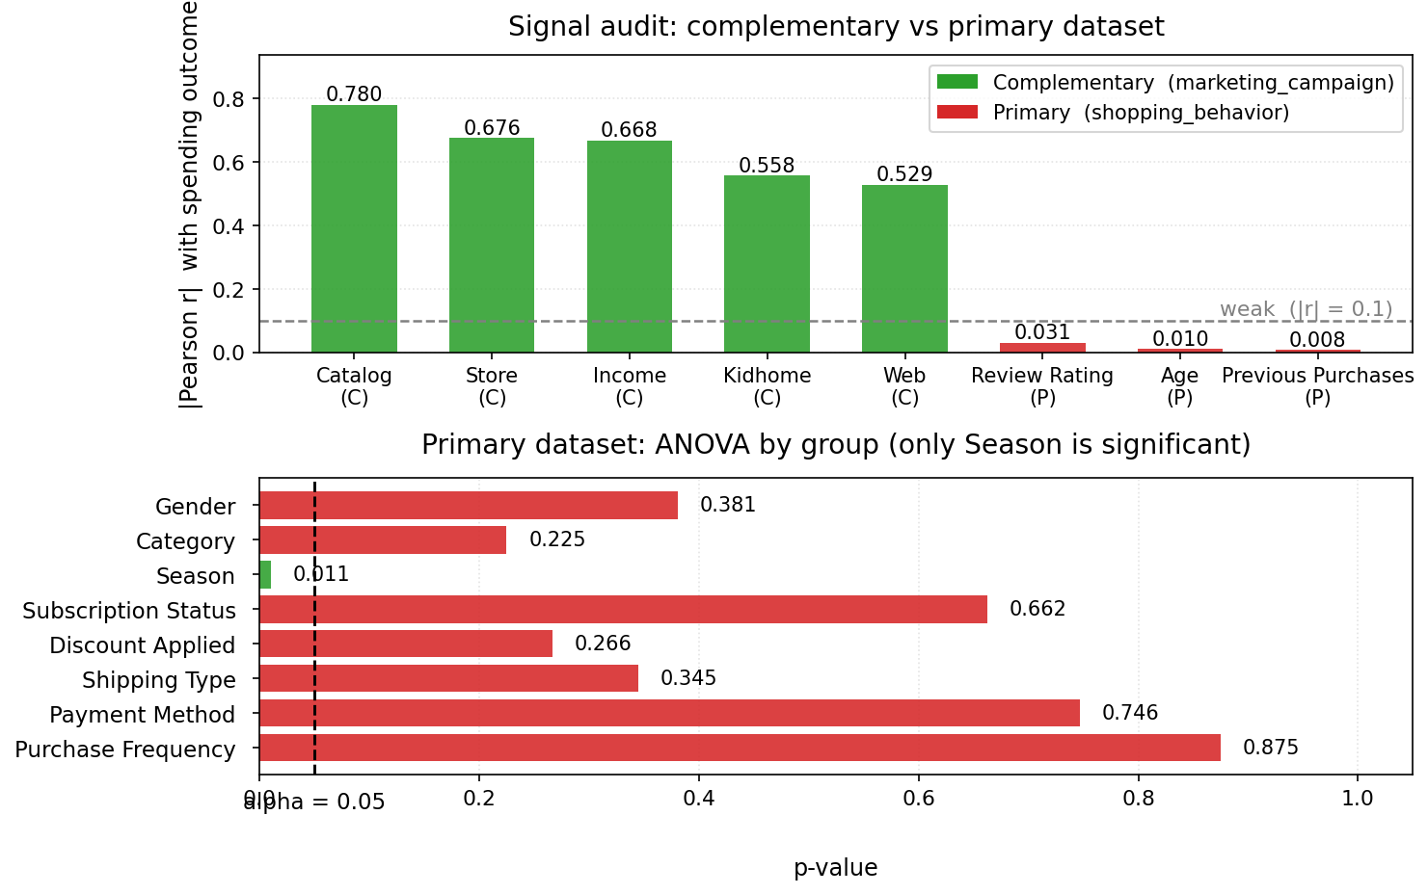
Figure 1. Data credibility audit. Upper: |Pearson r| with the spending outcome, complementary dataset (green, Customer Personality Analysis, n = 2,213 after cleaning) versus primary dataset (red, Shopping Behaviour, n = 3,900). Lower: one-way ANOVA p-values by grouping variable for the primary dataset; only Season (p = 0.011) falls below alpha = 0.05.
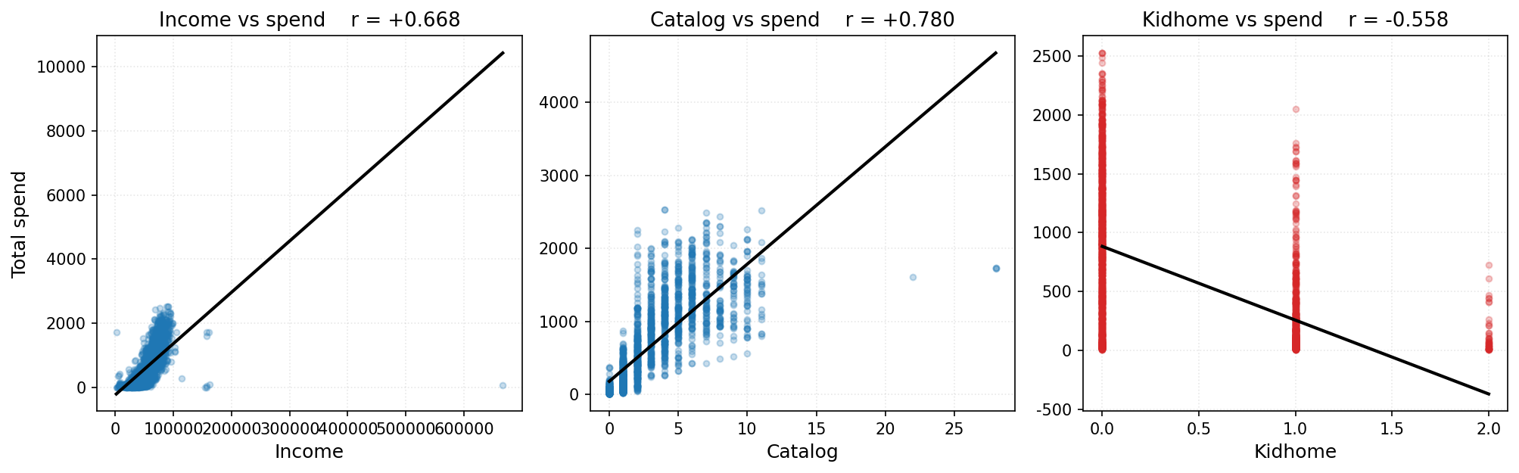
Figure 2. Drivers of total spend in the Customer Personality Analysis dataset (n = 2,213). Income r = +0.668, catalogue purchases r = +0.780, young children at home r = -0.558. Points are drawn at 25 percent opacity so that dense regions read as darker areas, and a least-squares line is fitted to each panel.

8. Risks, Limitations and Ethical Use
- Sample size: cleaning reduces the complementary dataset from 2,240 to 2,213 records — ample for correlation and regression, but it limits how finely the data can be segmented.
- Observational data: all findings are associations; spend and income may share unobserved drivers, so no causal language is used.
- Synthetic origin: the flat correlations are consistent with data generated without a real relationship. This is reported as a property of the source, not a finding about shoppers.
- Modelling assumptions: multicollinearity and heteroscedasticity are expected and will be reported rather than silently corrected. Both files are public teaching data with no identifying personal information.

9. Data Sources
Role | Dataset | Why it is used
Secondary (audit case) | Shopping Behaviour Dataset — Kaggle (shopping_behavior_updated.csv, 3,900 rows x 18 columns) | Kept from Assignment 01 but re-cast as the object of the audit (RQ1, RQ4) rather than as the modelling base.
Primary (modelling base) | Customer Personality Analysis — Kaggle (marketing_campaign.csv, 2,240 rows x 29 columns) | Carries measurable structure in spend; used for the RQ2 regression and RQ3 segmentation.

Direct links to the two datasets:
Shopping Behaviour Dataset:
Shopping Behaviour Dataset — Kaggle
Customer Personality Analysis:
Customer Personality Analysis — Kaggle
Both datasets are publicly available Kaggle tabular files in CSV form, downloaded and stored in the same folder as the notebook. The Customer Personality Analysis file is tab-separated despite its .csv extension and is read with sep='\t'. Both links are also recorded in the notebook header and in the final report.
Declaration of partnership: this proposal is submitted by Pair 05 of Class B, comprising MC641326 (QU YING) and MC641811 (LIU ZIXUAN). Both members contributed to the analysis and review reported above, and both will submit the same set of artifacts at their own submission link, personal forum and collaborative forum.

